A000-Afr-Ghana, Adanse Fomena region-Nsodie, Akan-Head-Female-Clay-1600s 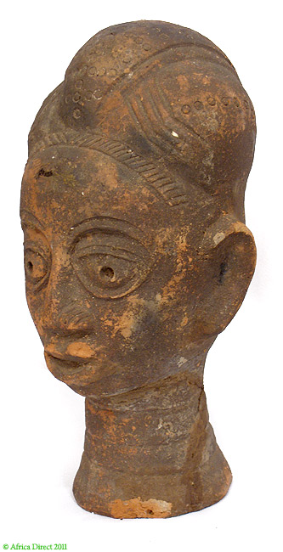 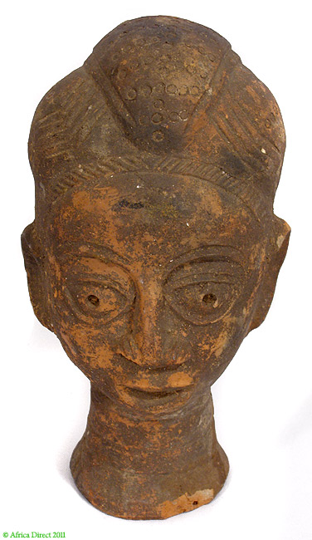 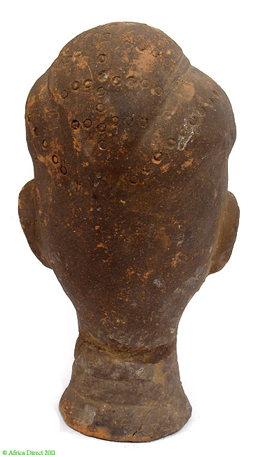

Figs. 1-3. Ghana, Adanse Fomena region-Nsodie, Akan-Head-Female-Clay-1600s **Case no.: 6**

**Accession Number: A000**

**Formal Label:** Ghana, Adanse Fomena region-Nsodie, Akan-Head-Female-Clay-1600s

**Display Description:**

The "*nsodie*" (meaning ‘thing placed on top’; also called *Mma*, *Nkua* or *Ohoni Ti*) is an idealized and stylized depiction of a deceased Akan royalty that seems to have been established in almost all of the Akan areas simultaneously in the seventeenth-century when the Akwamu empire was formed (Bellis 1982). The tradition appears to have continued in some Akan kingdoms of Ghana such as Twifo Heman until the early nineteenth century.

Thisterracotta head is known as a "*nsodie*" (meaning ‘thing placed on top’; also called *Mma*, *Nkua* or *Ohoni Ti*), which is an idealized and stylized depiction of a deceased Akan royal woman. She has an intricate hair style with a wedge-shaped crown (possibly of gold) that was positioned on top of the head to keep the hair in place that probably signified her royal lineage. Her neck is also elongated with several bands of copper or gold necklaces, a practice that was also reserved for royalty.

Opinions vary about the actual use of these heads. Some sources state that these heads were created to represent deceased chiefs and queens in burial and funerary celebrations while others point to the heads as focal effigies for commemorative rites (representing a vessel which encapsulates the wisdom, knowledge and experience of the deceased leader). However, such fundamental concepts as kra ("soul"), sunsum ("spirit"), and agyabosom ("father's deity"; the patrifilial group known as ntoro in Asante and nton in Takyiman Bron) may have different nuances of meaning in different Akan kingdom. As stylized portraits, they represented the individual by the traits identified with them during their lifetime. For example, the normally reddish-brown color of the clay might have red or white lines added to the forehead which may have indicated the individual's relationship to the mother's family.

*Nsodie* heads were believed to have been created by elderly female ceramic artists after the death of a prominent leader and placed in *asenie* (meaning ‘place of pots’) usually sacred forest groves on the outskirts of towns, locations at which villagers would make offering to the dead through the collection of *nsodie* heads. Other sources point to the fact that *nsodie* heads could also have been effigies for deities and divinity (*abosom*) which served as intermediary communicators between the realm of the living and divinity.

It is generally agreed that *nsodie* heads are not exact representations of leaders past but instead depict certain characteristics of the deceased, such as the individual’s hairstyle or scarification marks (LaGamma 2011).

Similar terracotta heads served as funerary portraits and memorials for the Akan peoples of and for the Agni and Krinjabo people who are coastal Akan in Cote d'Ivoire.

**LC Classification:**

**Date or Time Horizon:**

**Geographical Area:**

**Map:**

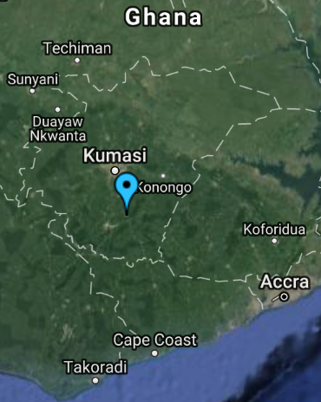

**Fig.**

**GPS coordinates:6o 17’ 0” N; 1o 31’ 0” W**

**Cultural Affiliation:** Akan

**Medium:** terracotta

**Dimensions:**

**Weight:**

**Condition: original**

**Provenance:**

**Discussion:**

Terracotta heads served as funerary portraits and memorials not only for the Akan peoples but also for the Agni and Krinjabo people who are coastal Akan in Cote d'Ivoire.

**References:**

LaGamma, Alisa. 2011. Heroic Africans: legendary leaders, iconic sculptures. New York : Metropolitan Museum of Art.